Java Basics Prashanth.S(19MID0020)

**Question**

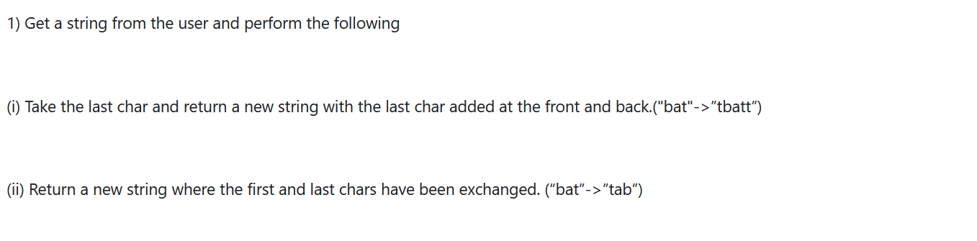

**Code**

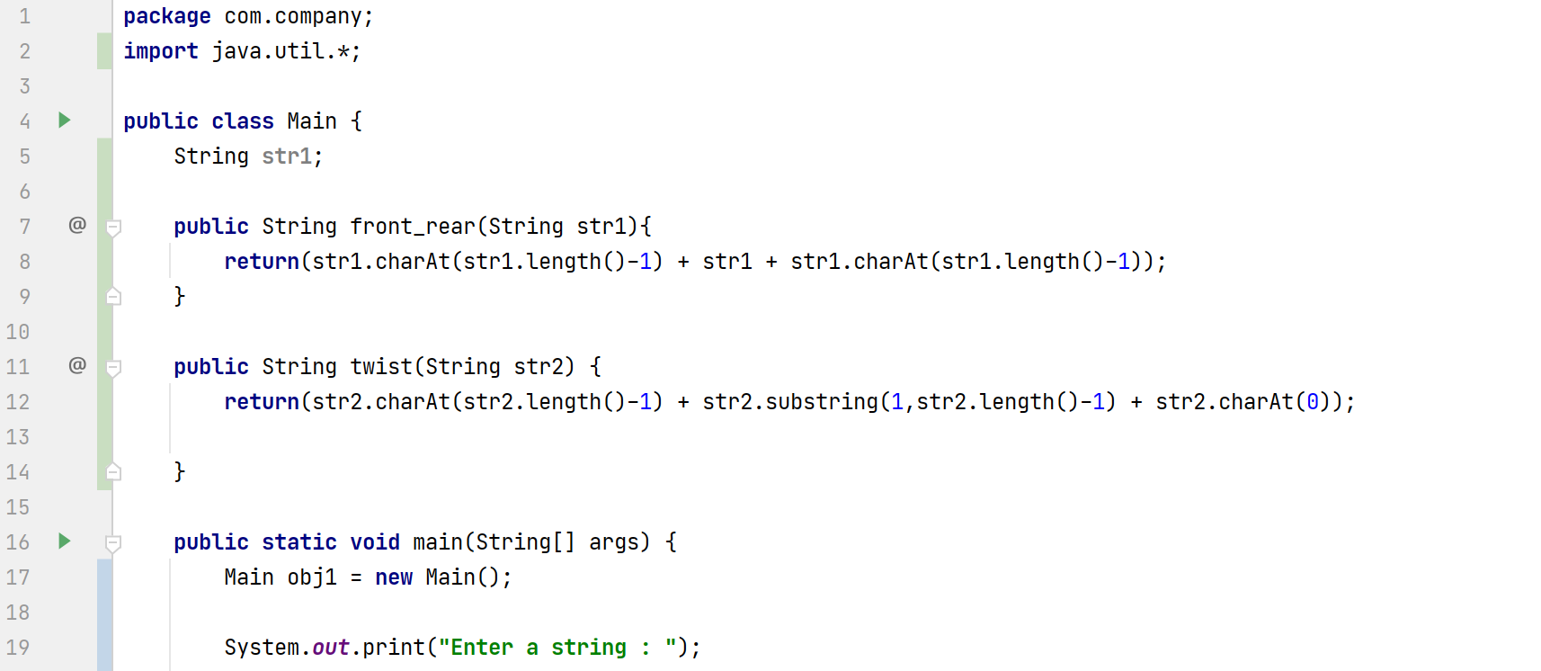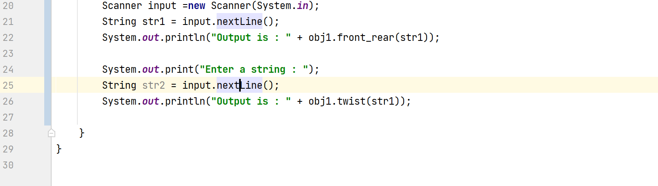

**Output**

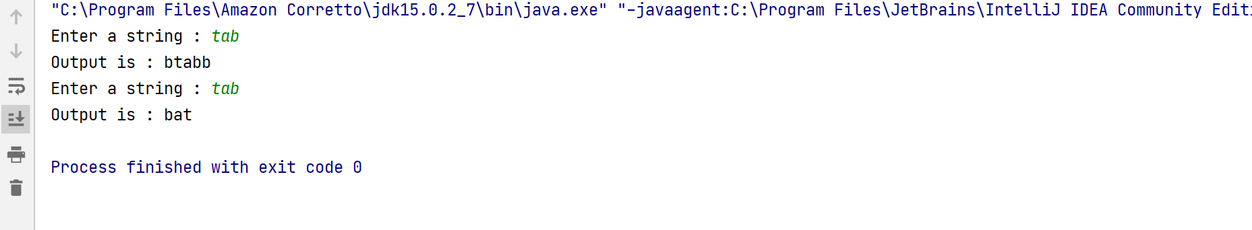

**Code**

**package** com.company;  
**import** java.util.*;  
  
**public class** Main {  
 String **str1**;  
  
 **public** String front_rear(String str1){  
 **return**(str1.charAt(str1.length()-1) + str1 + str1.charAt(str1.length()-1));  
 }  
  
 **public** String twist(String str2) {  
 **return**(str2.charAt(str2.length()-1) + str2.substring(1,str2.length()-1) + str2.charAt(0));  
  
 }  
  
 **public static void** main(String[] args) {  
 Main obj1 = **new** Main();  
  
 System.***out***.print(**"Enter a string : "**);  
 Scanner input =**new** Scanner(System.***in***);  
 String str1 = input.nextLine();  
 System.***out***.println(**"Output is : "** + obj1.front_rear(str1));  
  
 System.***out***.print(**"Enter a string : "**);  
 String str2 = input.nextLine();  
 System.***out***.println(**"Output is : "** + obj1.twist(str1));  
  
 }  
}

**Question**

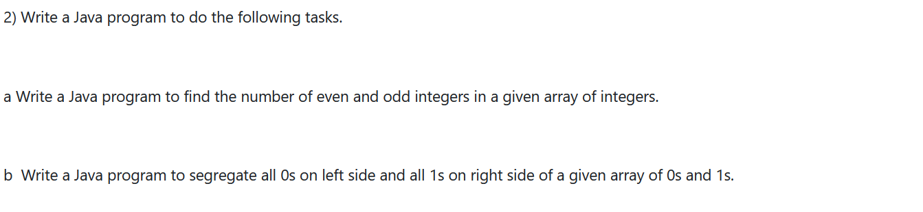**Code (2a)**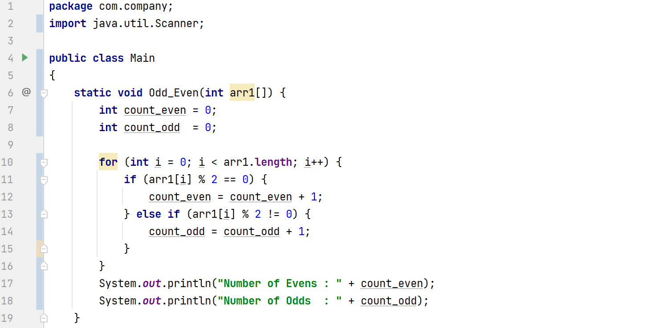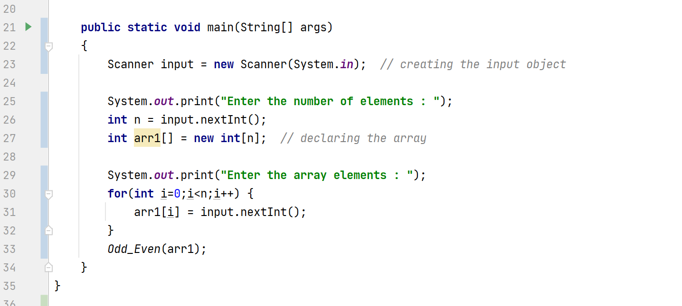

**Output**

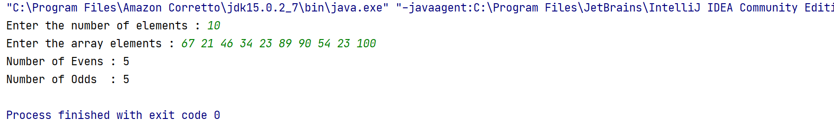

**Code (2a)  
package** com.company;  
**import** java.util.Scanner;  
  
**public class** Main  
{  
 **static void** Odd_Even(**int** arr1[]) {  
 **int** count_even = 0;  
 **int** count_odd = 0;  
  
 **for** (**int** i = 0; i < arr1.**length**; i++) {  
 **if** (arr1[i] % 2 == 0) {  
 count_even = count_even + 1;  
 } **else if** (arr1[i] % 2 != 0) {  
 count_odd = count_odd + 1;  
 }  
 }  
 System.***out***.println(**"Number of Evens : "** + count_even);  
 System.***out***.println(**"Number of Odds : "** + count_odd);  
 }  
  
 **public static void** main(String[] args)  
 {  
 Scanner input = **new** Scanner(System.***in***); *// creating the input object* System.***out***.print(**"Enter the number of elements : "**);  
 **int** n = input.nextInt();  
 **int** arr1[] = **new int**[n]; *// declaring the array* System.***out***.print(**"Enter the array elements : "**);  
 **for**(**int** i=0;i<n;i++) {  
 arr1[i] = input.nextInt();  
 }  
 *Odd_Even*(arr1);  
 }  
}

**Code (2b)**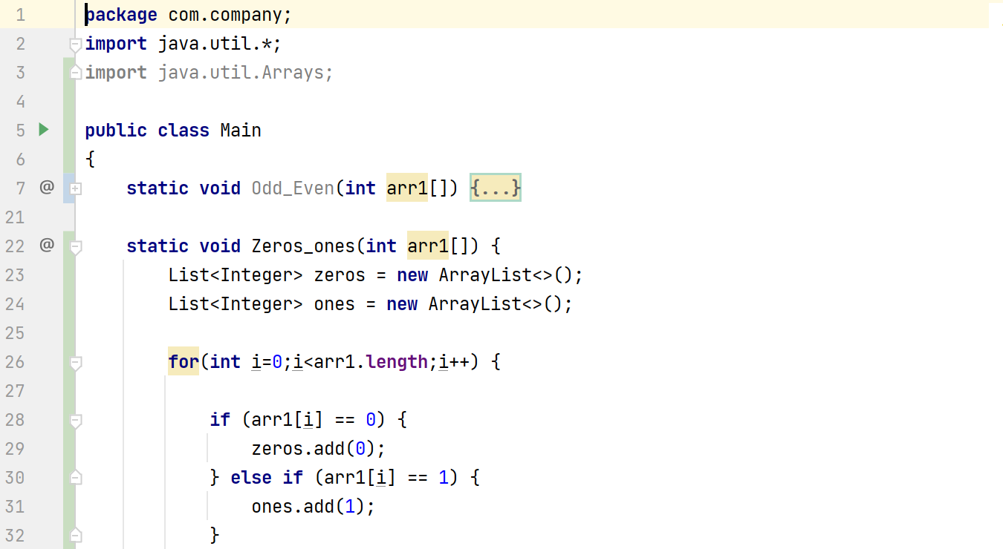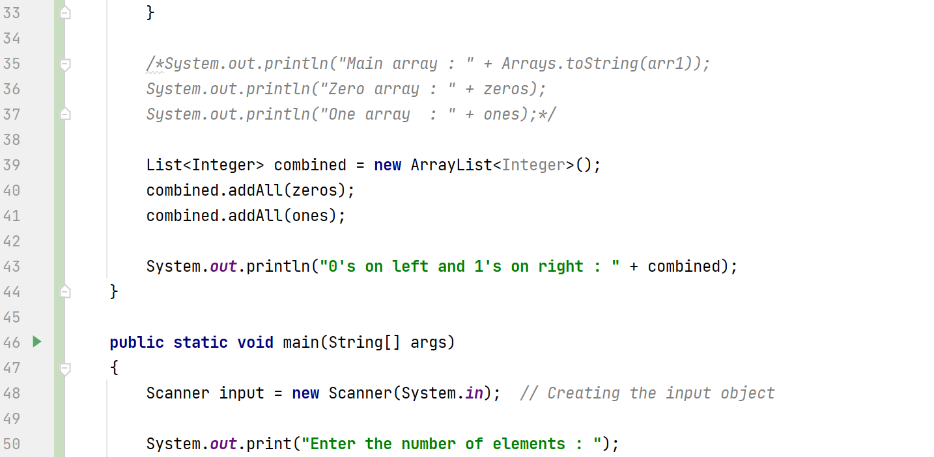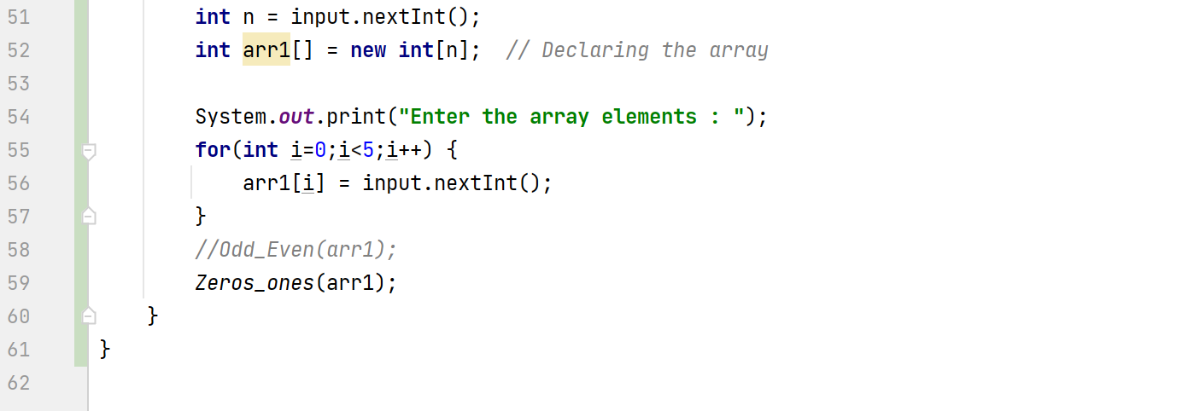

**Output**

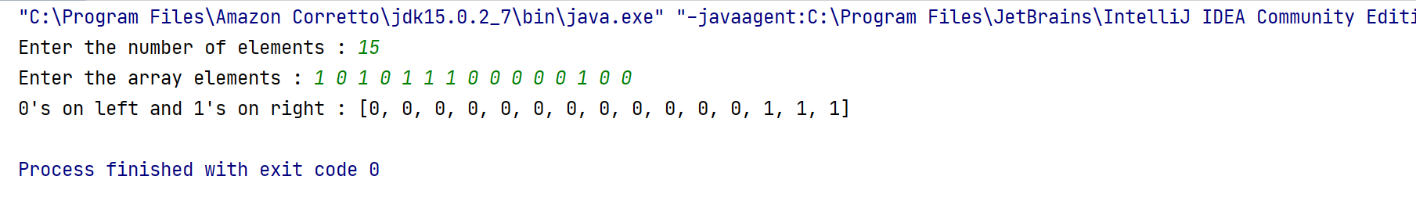

**Code (2b)**

**package** com.company;  
**import** java.util.*;  
**import** java.util.Arrays;  
  
**public class** Main  
{  
 **static void** Odd_Even(**int** arr1[]) {  
 **int** count_even = 0;  
 **int** count_odd = 0;  
  
 **for** (**int** i = 0; i < arr1.**length**; i++) {  
 **if** (arr1[i] % 2 == 0) {  
 count_even = count_even + 1;  
 } **else if** (arr1[i] % 2 != 0) {  
 count_odd = count_odd + 1;  
 }  
 }  
 System.***out***.println(**"Number of Evens : "** + count_even);  
 System.***out***.println(**"Number of Odds : "** + count_odd);  
 }  
  
 **static void** Zeros_ones(**int** arr1[]) {  
 List<Integer> zeros = **new** ArrayList<>();  
 List<Integer> ones = **new** ArrayList<>();  
  
 **for**(**int** i=0;i<arr1.**length**;i++) {  
  
 **if** (arr1[i] == 0) {  
 zeros.add(0);  
 } **else if** (arr1[i] == 1) {  
 ones.add(1);  
 }  
 }  
  
 */*System.out.println("Main array : " + Arrays.toString(arr1));  
 System.out.println("Zero array : " + zeros);  
 System.out.println("One array : " + ones);*/* List<Integer> combined = **new** ArrayList<Integer>();  
 combined.addAll(zeros);  
 combined.addAll(ones);  
  
 System.***out***.println(**"0's on left and 1's on right : "** + combined);  
 }  
  
 **public static void** main(String[] args)  
 {  
 Scanner input = **new** Scanner(System.***in***); *// Creating the input object* System.***out***.print(**"Enter the number of elements : "**);  
 **int** n = input.nextInt();  
 **int** arr1[] = **new int**[n]; *// Declaring the array* System.***out***.print(**"Enter the array elements : "**);  
 **for**(**int** i=0;i<5;i++) {  
 arr1[i] = input.nextInt();  
 }  
 *//Odd_Even(arr1);  
 Zeros_ones*(arr1);  
 }  
}

Github :[**https://github.com/PrashanthSingaravelan/WinterSemester-2021/tree/main/CSI2008%20Programming%20in%20JAVA/JAVA%20lab%20practice/Java%20Basics**](https://github.com/PrashanthSingaravelan/WinterSemester-2021/tree/main/CSI2008%20Programming%20in%20JAVA/JAVA%20lab%20practice/Java%20Basics)